Lab 2 placeholder:

Task 1:
To complete the first set of tasks I made a new local repository called ArchOSC assignment with the photos folder added into it. After that, I created a new document called lab 2 placeholder which was then saved into the local repository. Once the word doc was saved into the local repository, I took a screenshot of the repos contents which then got pasted into the word doc.

Task 2:
For the second task I had to initialise a new repo in the ArchO9SC assignment folder. The way that I did this was by opening the command line inside the ArchOSC assignment folder. Then once I had the command line open in the correct folder, I had to type git init into the command line. What this did is it initialised an empty git repository in the folder.

Task 3:
For the 3rd task I had to produce a repo on Github that my local repo can link to. To produce this I went onto Github and selected the new repo button; this took me to an options screen. I made the repo private, include a README.md as well as a. gitignore visual studio. Once I selected myself as the owner I had a new repo.

Taks 4:
For this task I had to link both my local and online repo together and then pull the contents from my repo on Github onto the local repo. The way I achieved this is by using the command git remote add origin and then pasted the link to my online repo into the command. By using this command, I told the local repo where it should be looking if it is pulling or pushing information. Then to add the contents of my repo on Github to my local repo I used git pull origin main. This worked because I created that link between the two repos; this pulled the contents of my online repo to my local one.

Task 5:
The fifth task required me to produce a website and save it into my local repo. To start I opened a new text file in Visual Studio code; once I made the text file copied the provided code into the text file. Once the code had been pasted into the file, I saved the file into my local repo and called it indesx.html. Now that the file has been saved onto my local repo I opened the file and checked the webpage online and it worked.
Task 6:
For task 6 I had to commit all my files to my local repository; the way I did this was using git status to check what files were in my local folder, then using git add . to add all the files from the folder to the local repo and then using git commit to save all the files onto the local repository as well as leaving a comment about what had just been committed.

Task 7:
For this next task I was made to push my committed files in my local repo to my repo in Github. To do this I used Git status to check if any files needed committing, I used the command git push and was then prompted to type the command git push - - set – upstream origin main which pushed the files to my Github repo.

Task 8:
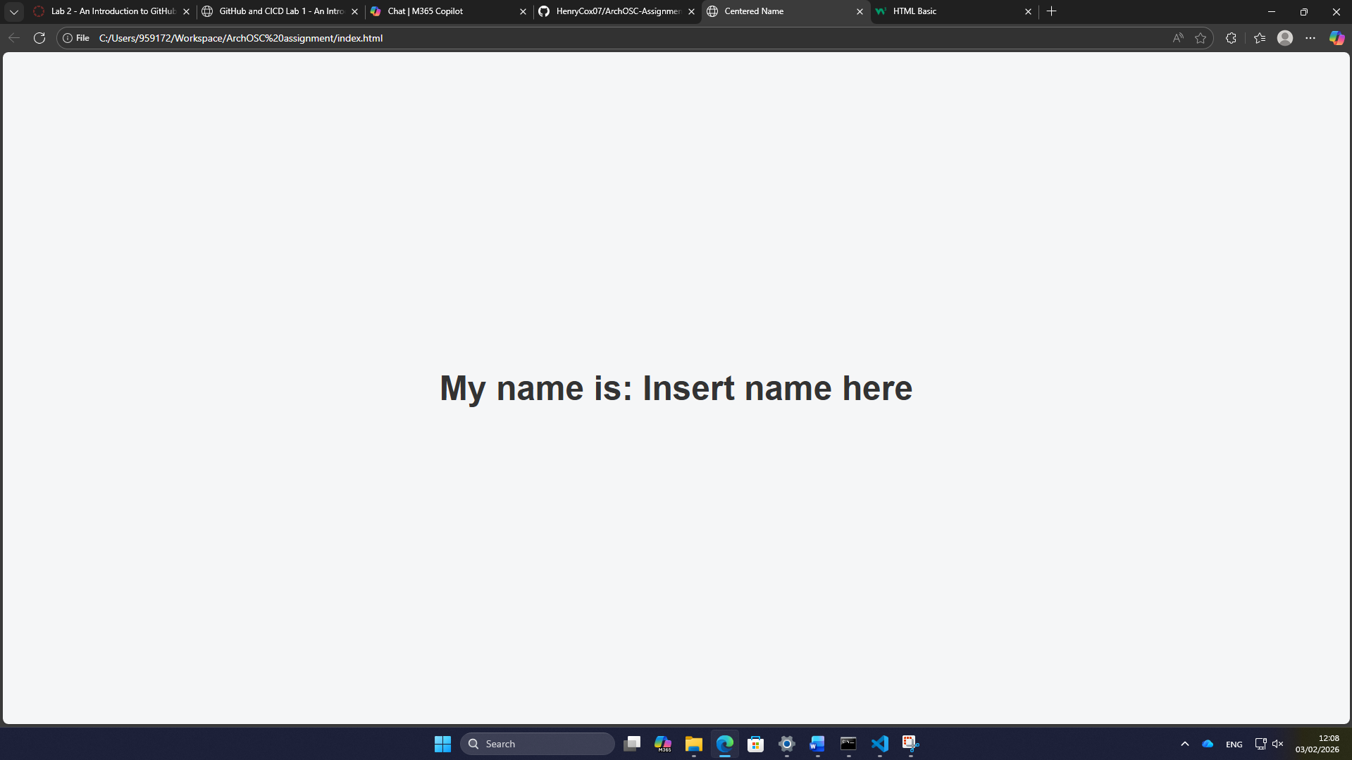
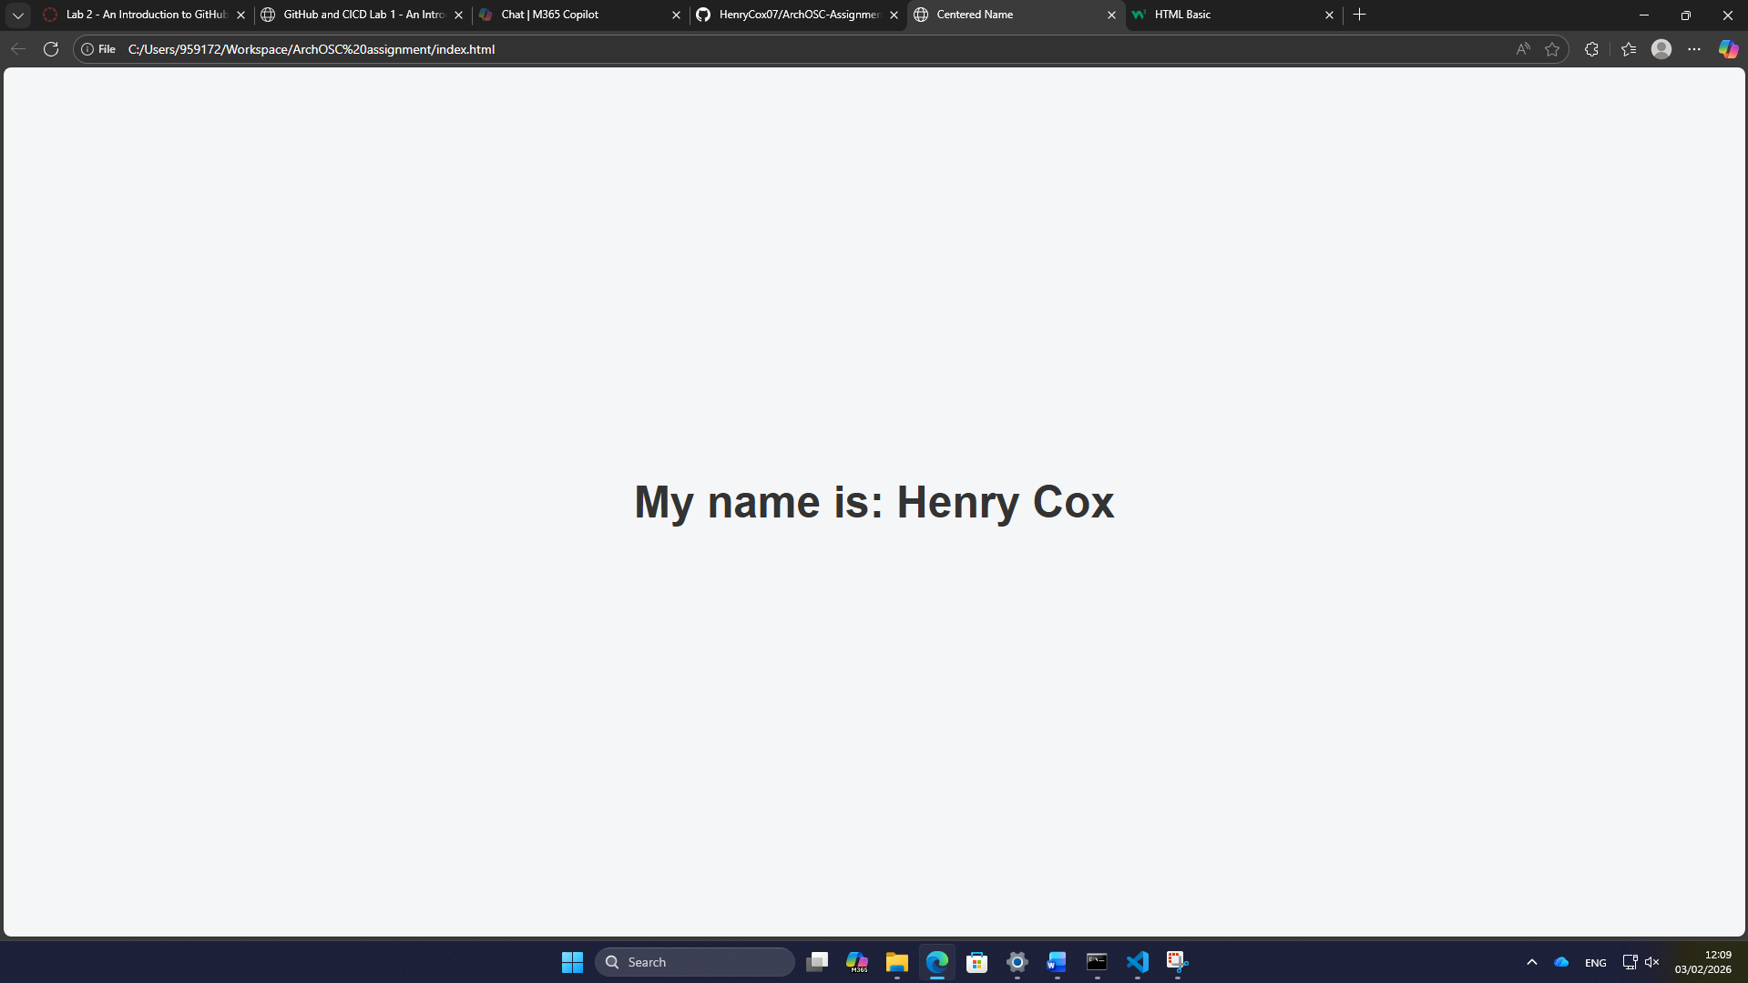
For the first set of changes I went into the source code and altered the text in the body <h1> from insert name here to my name.
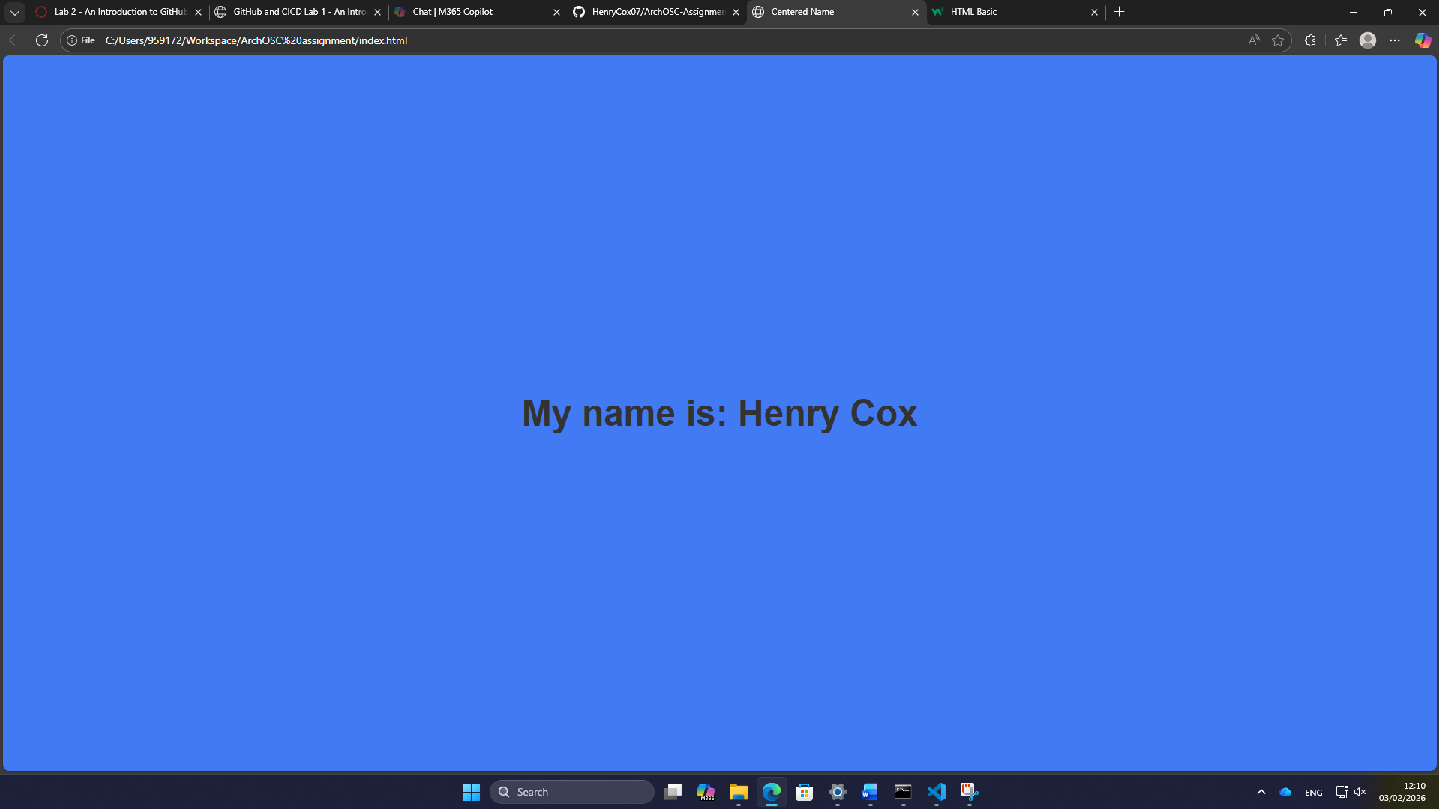
For the second change to the website, I altered the colour of the page in the source code from white to blue. I did this by going to background colour in the “style” body and changing the colour using the dropdown.

Task 9:
For this task I had to deploy the website onto Github; the way I did this is I went to my settings on Github to allow for deployments to be made. Then I directed the deployment to my main branch and saved the changes. When checking the deployment my website was there.

